Sample Press Release

Date:
Contact:
Phone:
Email:

Celebrate Building with Biology [at name of your organization]!
[Insert your local Building with Biology location, dates, and specific activity information here.]
The Building with Biology event at [name of your organization] is part of a nationwide festival of educational programs designed to encourage conversations between the public and scientists. This exciting event provides an opportunity to learn about the emerging field of synthetic biology and talk with real scientists doing this work!

The Building with Biology project is funded by the National Science Foundation and led by the Museum of Science, Boston. Building with Biology kits are developed and distributed nationwide in collaboration with the American Association for the Advancement of Science (AAAS), BioBuilder Educational Foundation, the National Informal STEM Education Network, Science Museum of Minnesota, Sciencenter, and Synthetic Biology Engineering Research Center (Synberc). Events are taking place at over 150 museums and institutions throughout the country from June to September, 2016.

Building with Biology events provide a special opportunity for scientists and the public to interact directly and to learn from each other. These activities and conversations encourage public audiences to share ideas and opinions about how they want to see these new technologies developed and adopted. And scientists, too, have the chance to listen to those views, share their own ideas, and to consider ways public comments can affect their research.
Participants at a Building with Biology event can expect fun hands-on activities facilitated by scientists in the field of biology, synthetic biology, genetics, or other related science fields. Visitors will design a “super organism” to solve a problem, extract DNA from wheat germ, and discuss which future technologies they’d support. These activities are designed to introduce guests to synthetic biology content and promote informal, two-way conversations between the scientists and visitors about how synthetic biology is interconnected with our society.
[insert information about forum events or other special activities that your location may host.]

More about the
Multi-Site Public Engagement with Science-Synthetic Biology project
and the National Informal STEM Education Network
Project website: www.buildingwithbiology.org
The Multi-Site Public Engagement with Science—Synthetic Biology project is led by the Museum of Science, Boston in collaboration with:
- American Association for the Advancement of Science (AAAS): www.aaas.org
- BioBuilder Educational Foundation: www.biobuilder.org
- National Informal STEM Education Network: www.nisenet.org
- Science Museum of Minnesota: www.smm.org
- Sciencenter, Ithaca: www.sciencenter.org
- Synthetic Biology Engineering Research Center (Synberc): www.synberc.org

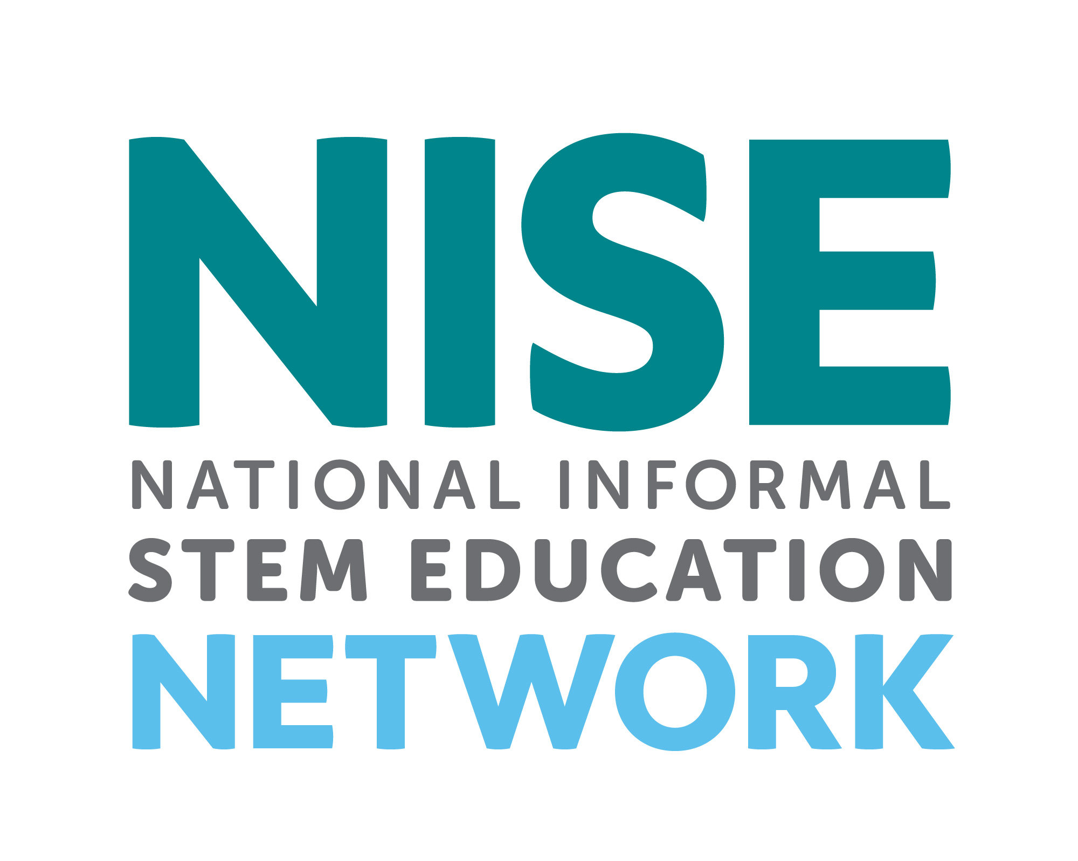

The Multi-Site Public Engagement with Science—Synthetic Biology project is supported by the National Science Foundation under Grant Number DRL-1421179. Any opinions, findings, or conclusions expressed in this material are those of the authors, and do not necessarily reflect the views of the National Science Foundation.

